
Luke Charity Clinic

8905 Ray Rd., Raleigh, NC 27613
(919) 870-9070

In-House Dental Patient Referral Form

Date: ______________________
Patient's Name: __________________________________________
Date of Birth: ________________________ Telephone#: _________________________
Referring Dentist: ________________________________________
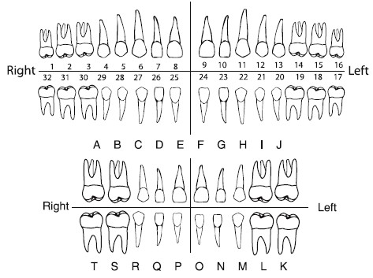
Reason for referral: _____________________________________________________________
_____________________________________________________________________________
_____________________________________________________________________________
_____________________________________________________________________________
_____________________________________________________________________________
Dentist's Signature: ____________________________________

